Orbital Sander
The Random Orbital Sander Safety Sheet
DO'S
- Examine the material you are sanding. Make sure there are no nails, splits or loose knots.
- Clamp down all work being sanded
- Always wear a mask. DUST HAZARD with this tool is high.
- Use a dust collection bag to reduce dust.
- Replace sanding disk if edges are worn out.
DON'TS
- Do not plug in until all adjustments have been made.
- Do not apply excessive force when sanding
- Do not leave sander operating unsupervised.

Question 1.  I have read and understood the DO'S AND DON'TS on the safe use of the orbital sander. In addition proper orbital sander use has been clearly demonstrated and explicitly explained to me by my teacher. |  | 
( ) | True
( ) | False

Question 2.
All work should be clamped securely to the workbench when sanding with powered sanders.
( ) | True
( ) | False

Question 3.
Select the Personal Protective Equipment you will need when carrying out any wood sanding operation.
[ ] | Protective Eye Shields
[ ] | Fully enclosed leather shoes.
[ ] | Apron for torso protection

Question 4.
Match the following items to reduce hazards
Lung Damage |  | Make sure the work surface is free from nails, knots, and other foreign objects.
Checking that the timber is safe for use |  | Always wear a dusk mask when sanding.
Eye damage |  | Wear eye shields

Question 5.
Never leave the tool switched on and turn the power off at the power source.
( ) | True
( ) | False

Question 6.  Hand held sanders cause a great deal of noise. Choose the item of Personal Protective Equipment which will protect you.  (Type: Multiple Choice, Points: 10, Attempts: 1) |  | 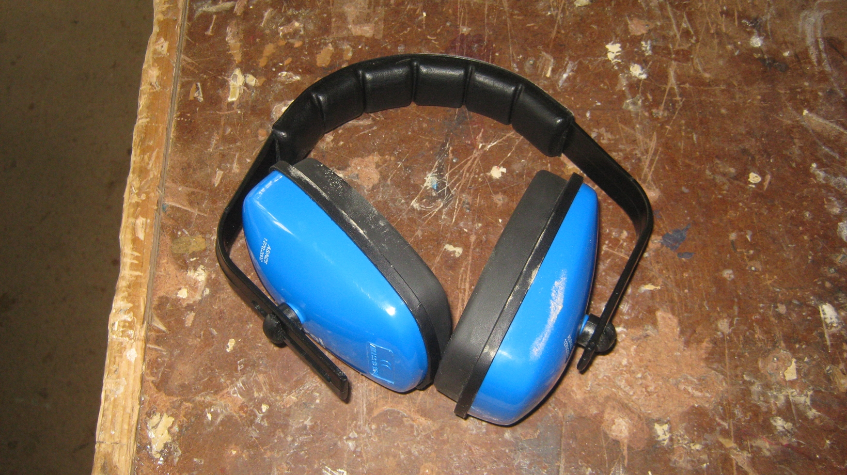
( ) | Ear Muffs / Plugs
( ) | Eye Shields.
( ) | Apron.
Question 7.  A dust mask and dust extraction should be used whenever possible when using the random orbital sander. |  | 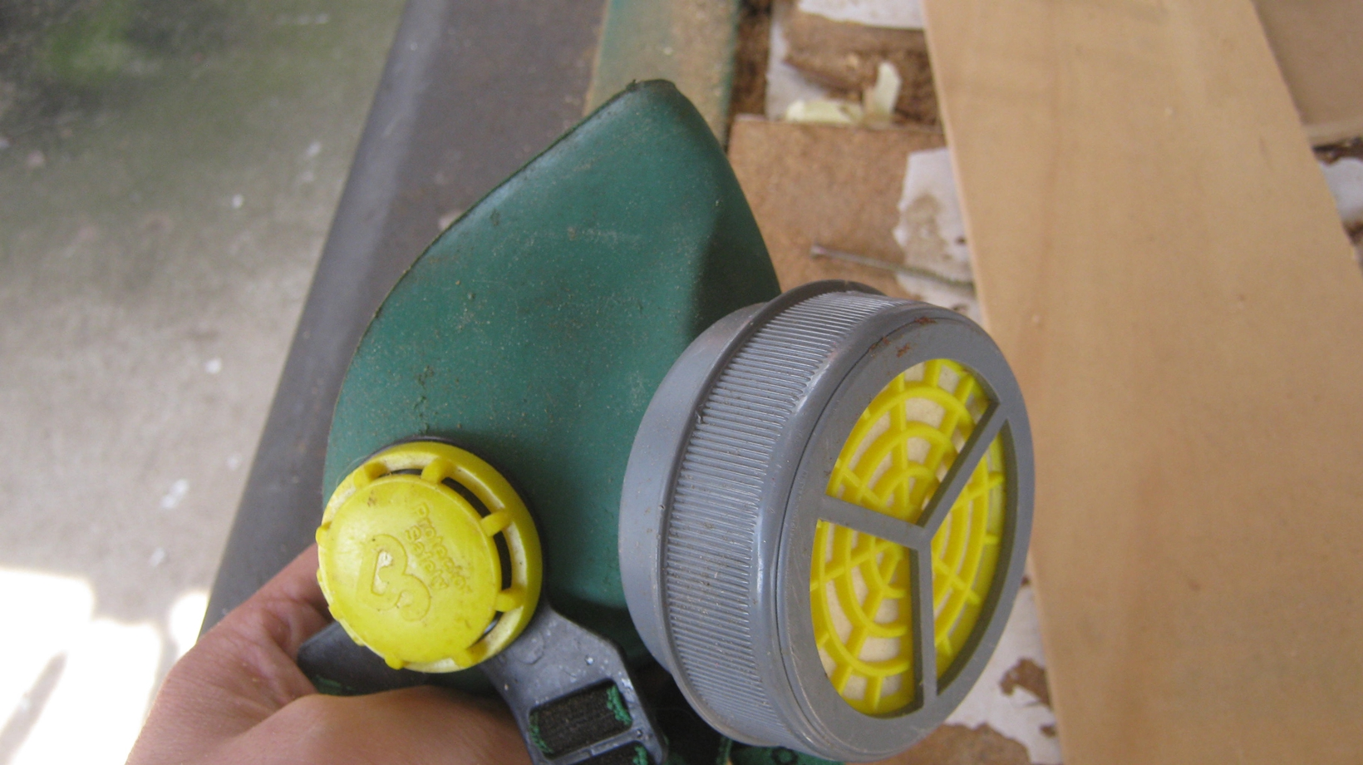
( ) | True
( ) | False
Question 8.  Ensure that the orbital sander is unplugged before making adjustments such as changing the sanding pad.  (Type: True/False, Points: 10, Attempts: 1) |  | 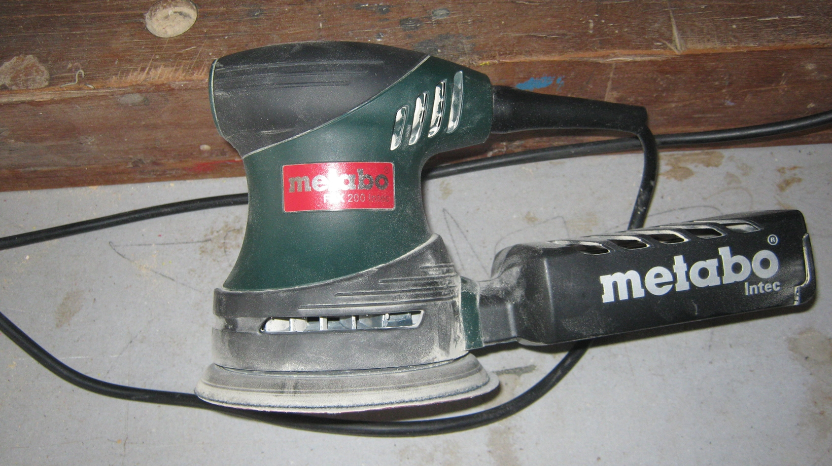
( ) | True
( ) | False

